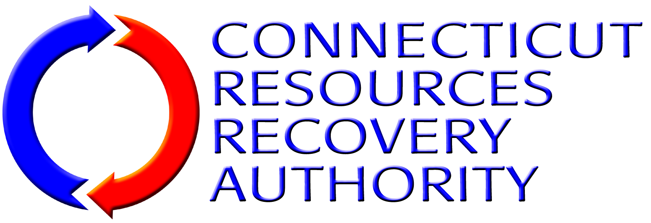
BUSINESS EXCEPTION FORM
Using this form (add additional sheets of paper as needed), the Proposal Proposer (hereinafter collectively referred to as “Contractor”) shall identify any portion of the Work/Services required or described in the RFP Package of Documents and the “Operation And Maintenance Of The Mid-Connecticut Jet Turbine Facility Agreement” (Attachment 1 to this RFP) that Contractor desires to take exception to, if any. Contractor shall be specific regarding any exceptions listed. Contractor shall describe in detail the portion(s) of the Work/Services Contractor is taking exception to and why. Contractor shall also describe what, if any, alternative Work/Services or conditions Contractor is willing to provide or accept as a substitution for the Work/Services or business terms to which Contractor has taken exception, if any. If Contractor does not take exception to any portion of the Work/Services required or described in this RFP Package Documents and the Agreement, Contractor shall simply indicate below that Contractor “takes no exceptions”, and submit this form along with the other PROPOSAL forms as part of its PROPOSAL submittal. Note that CRRA will consider only those items identified by Contractor on this Business Exception Form. Also note that pursuant to State of Connecticut statutes and regulations, the Agreement contains a number of provisions that CRRA, as a quasi-public entity, is required to incorporate in all of its contracts and, therefore, cannot be waived.
I Proposer am interested in providing the subject services and indicate below for CRRA’s review and consideration, the material terms and conditions under which proposer would serve as Operator.
Description of Exception Item |  | Reason for Exception | Proposed Alternative
1.
2.
3.
4.
5.
6.
7.
8.

